User Management with Role

First download the Zip on github.com



Unzip the files and use vcs as you text editors

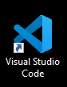

This is you first look,

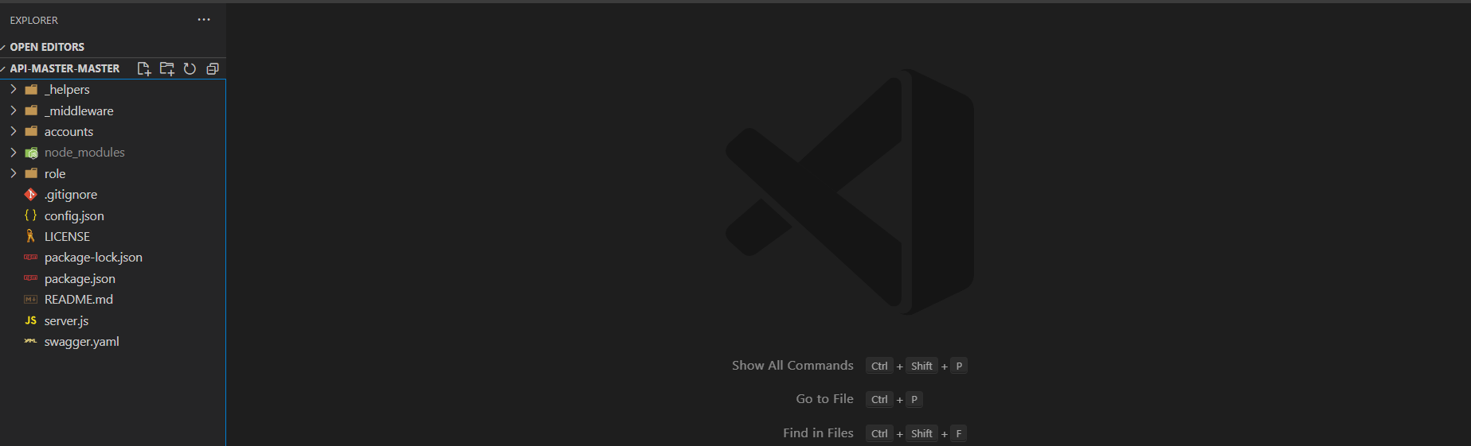

Now open new terminal.



Type “npm install or npm i” Wait until the installation in done.

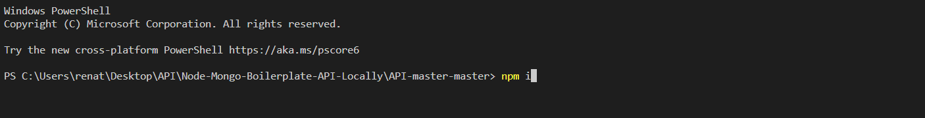

After installing, Copy the account file

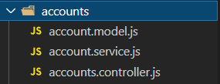

And rename the files to role

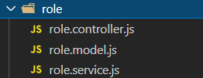

After that you can now change the controller, model and service code.

Here are the screen shot.

role.controller.js

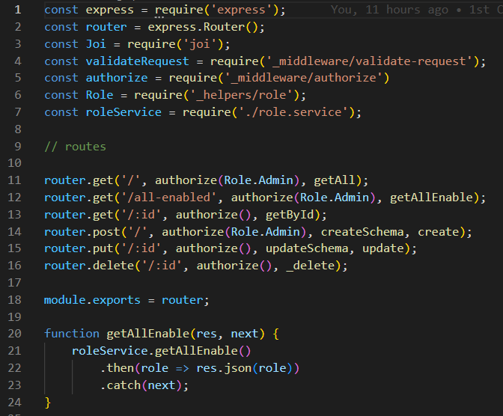

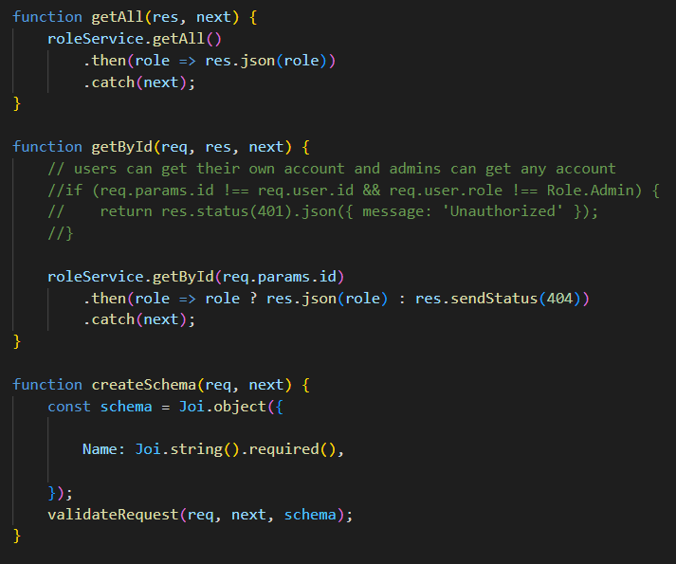 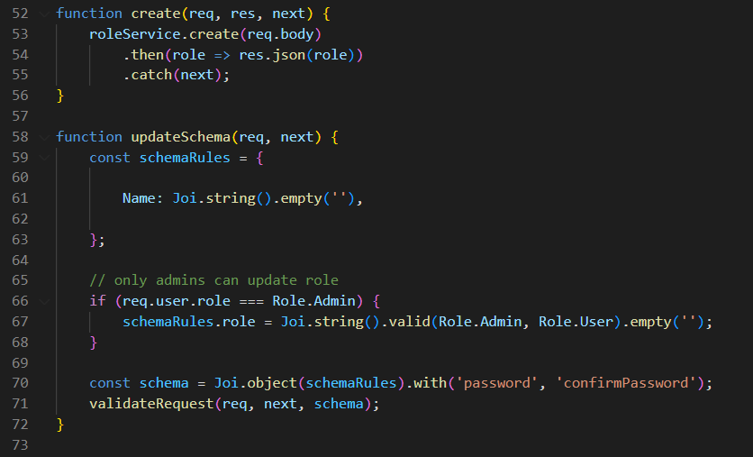

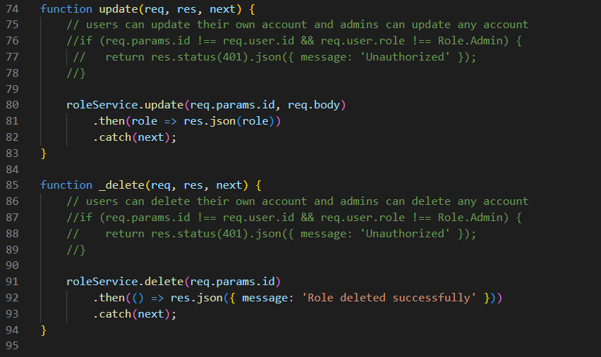

role.model.js

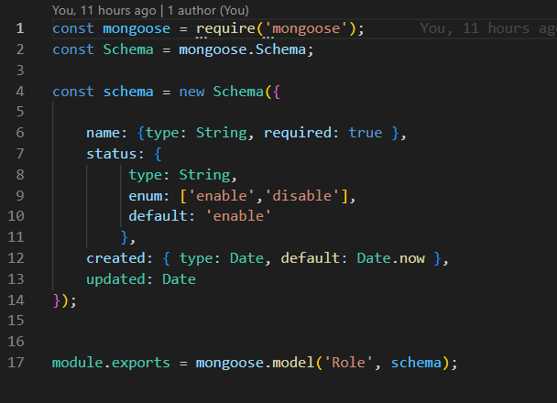

role.service.js

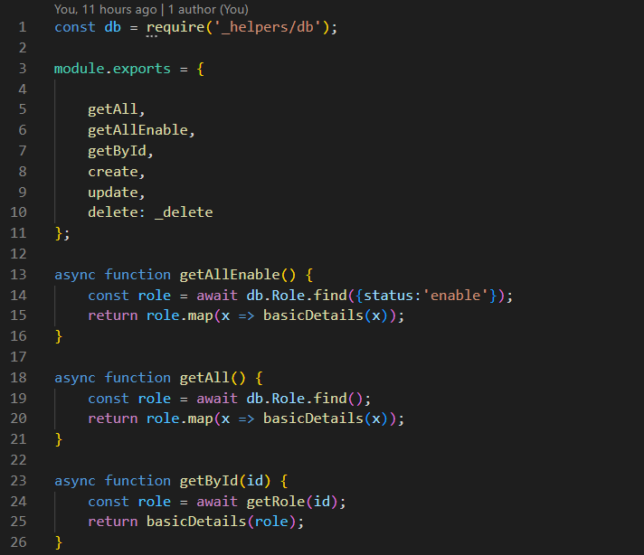

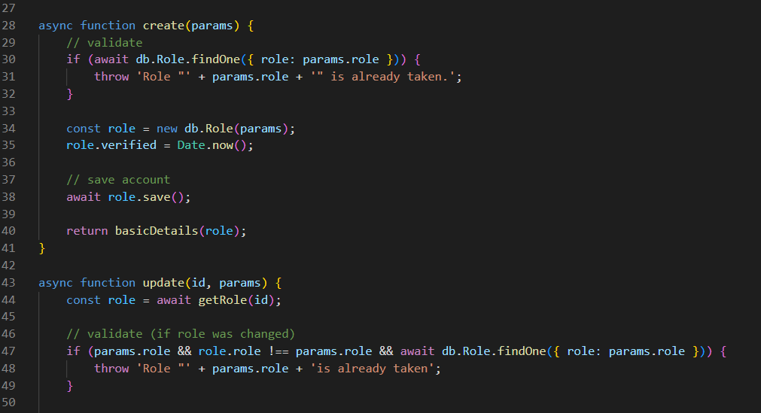

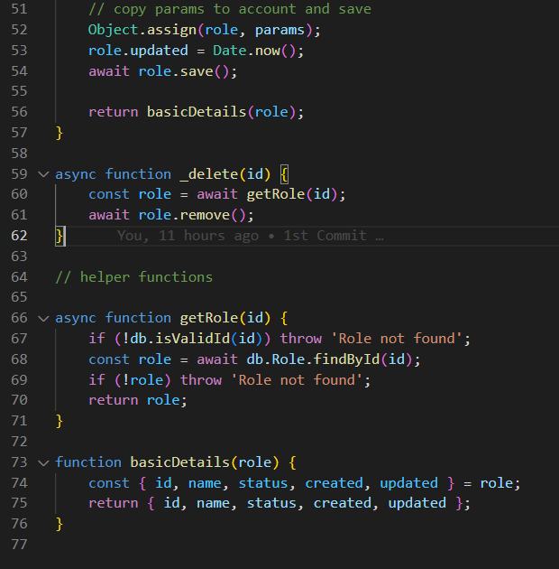

After you edit the codes

Don’t forget to edit the





Your done with the API

Angular-10-App-with-the-Node-Boilerplate-API-master

Download sa Zip Files and Unzip it on the folder. same on our API.

And npm install or npm i

First go to scr/app and trace the routes

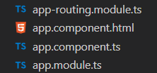

Add to this code to 



scr/app/admin copy the  code.

You can edit the files and code, change the accounts or account to role or roles

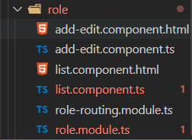

role.module.ts

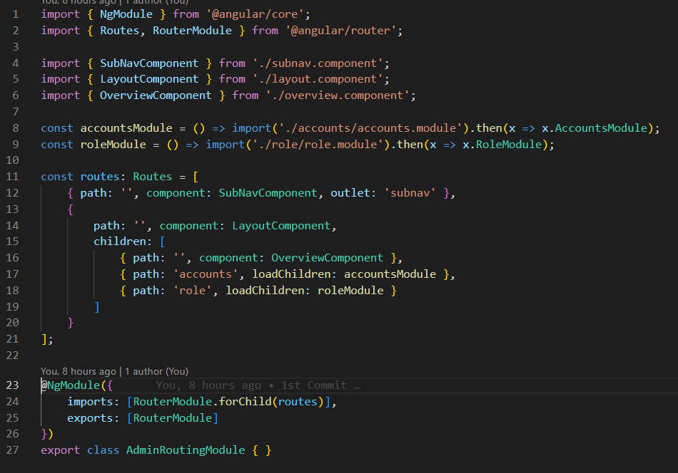

Role.routing.module.ts

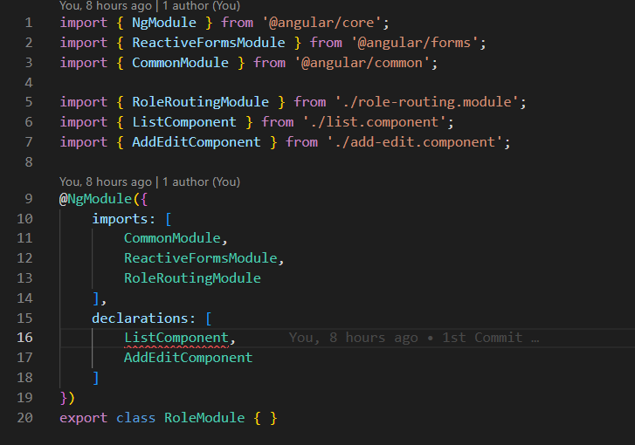

list.component.ts

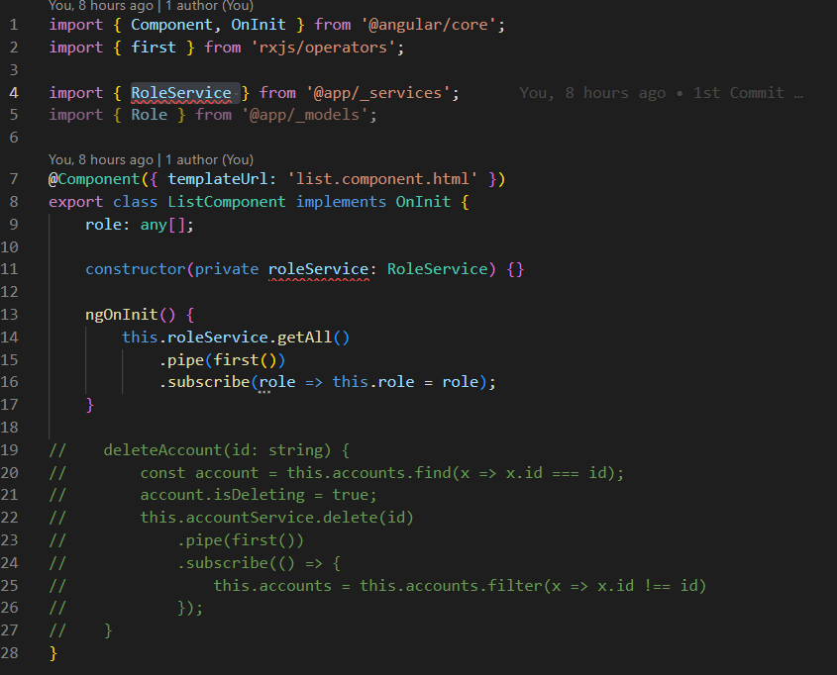

There is error on my angular 10 but I will fix this soon , I need to study and angular and the mongoose.

Study Source  
[Mongoose v6.3.8: SchemaTypes (mongoosejs.com)](https://mongoosejs.com/docs/schematypes.html#objectids)

[Providers - Angular Book (angular-book.dev)](https://angular-book.dev/ch06-03-providers.html)